Making a Flip Book
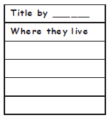
Any sized paper can be used. The number of sheets can also be varied to suit your needs. These directions describe the process as it was done for this project.
- Place three pieces of 12” x 18” construction paper in a stack with long edges aligned and short edges (ends) staggered about an inch.

- Fold edges over to reveal the staggered spacing. Crease and staple along the top.

- Label the tabs for each page topic.
Title by
Where the y live
What they e at
Interesting f acts
About the author
Resources

